LetsUpgrade AWS Essentials Assignment

**Project 1**

1. Create Windows Instance and create IIS Webserver
2. Public DNS: <http://ec2-13-58-170-80.us-east-2.compute.amazonaws.com/>
3. Public IP: <http://13.58.170.80/>

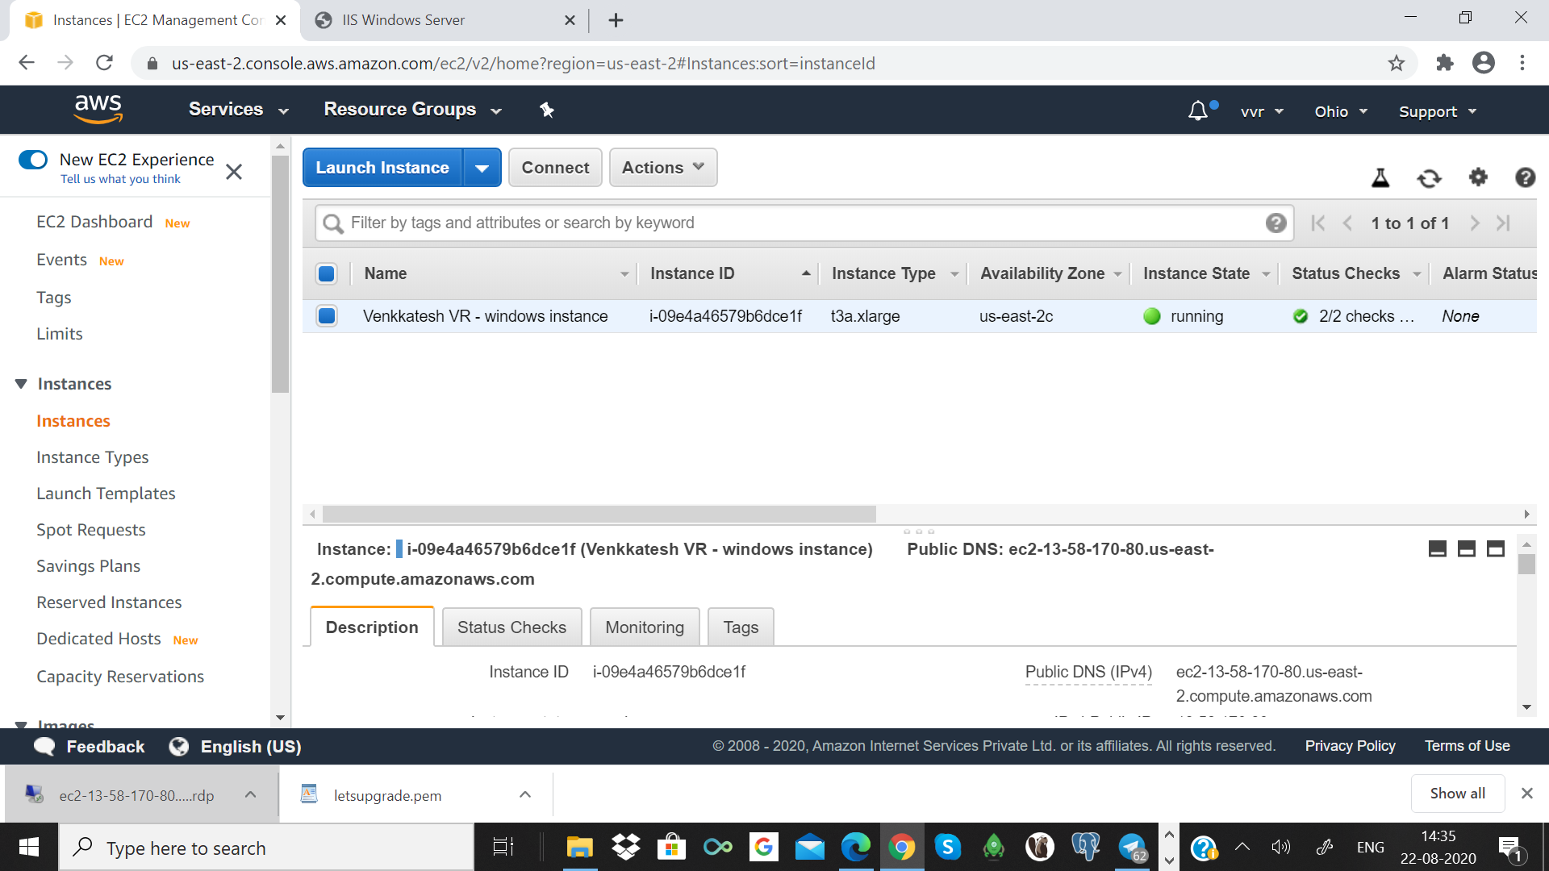

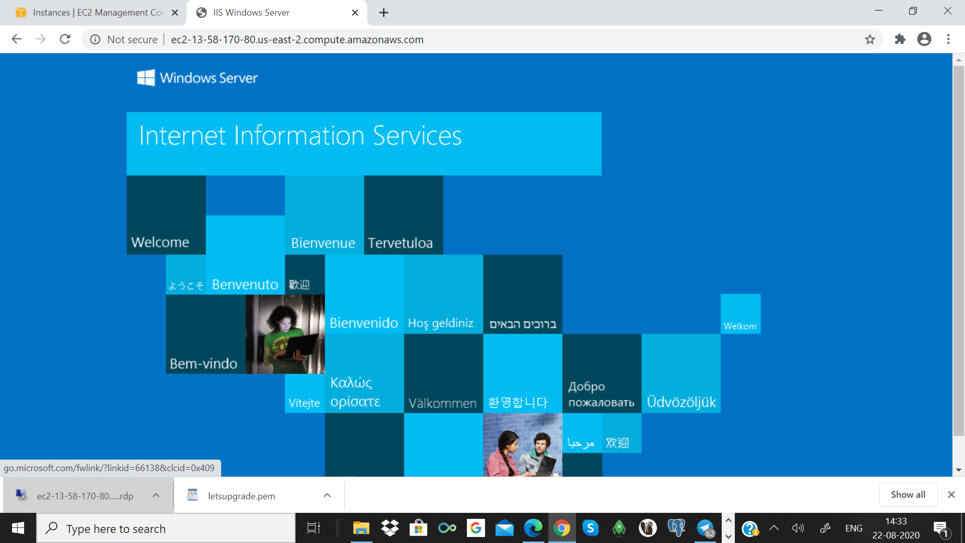

**Project 2**

Create Ubuntu Instance and install Nginx webserver

Public DNS: ec2-18-218-201-152.us-east-2.compute.amazonaws.com

Public IP: <http://18.218.201.152/>

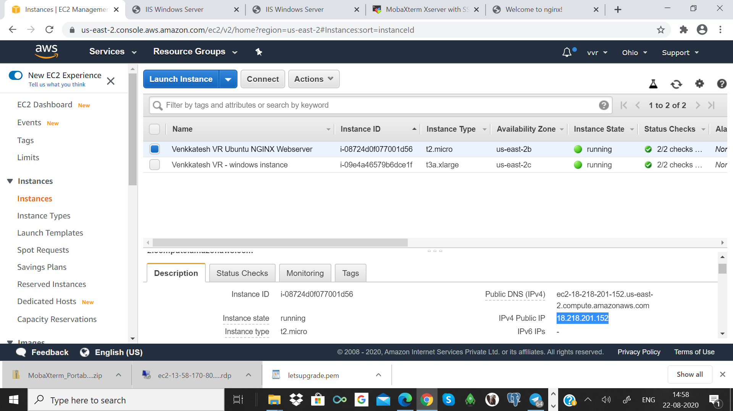

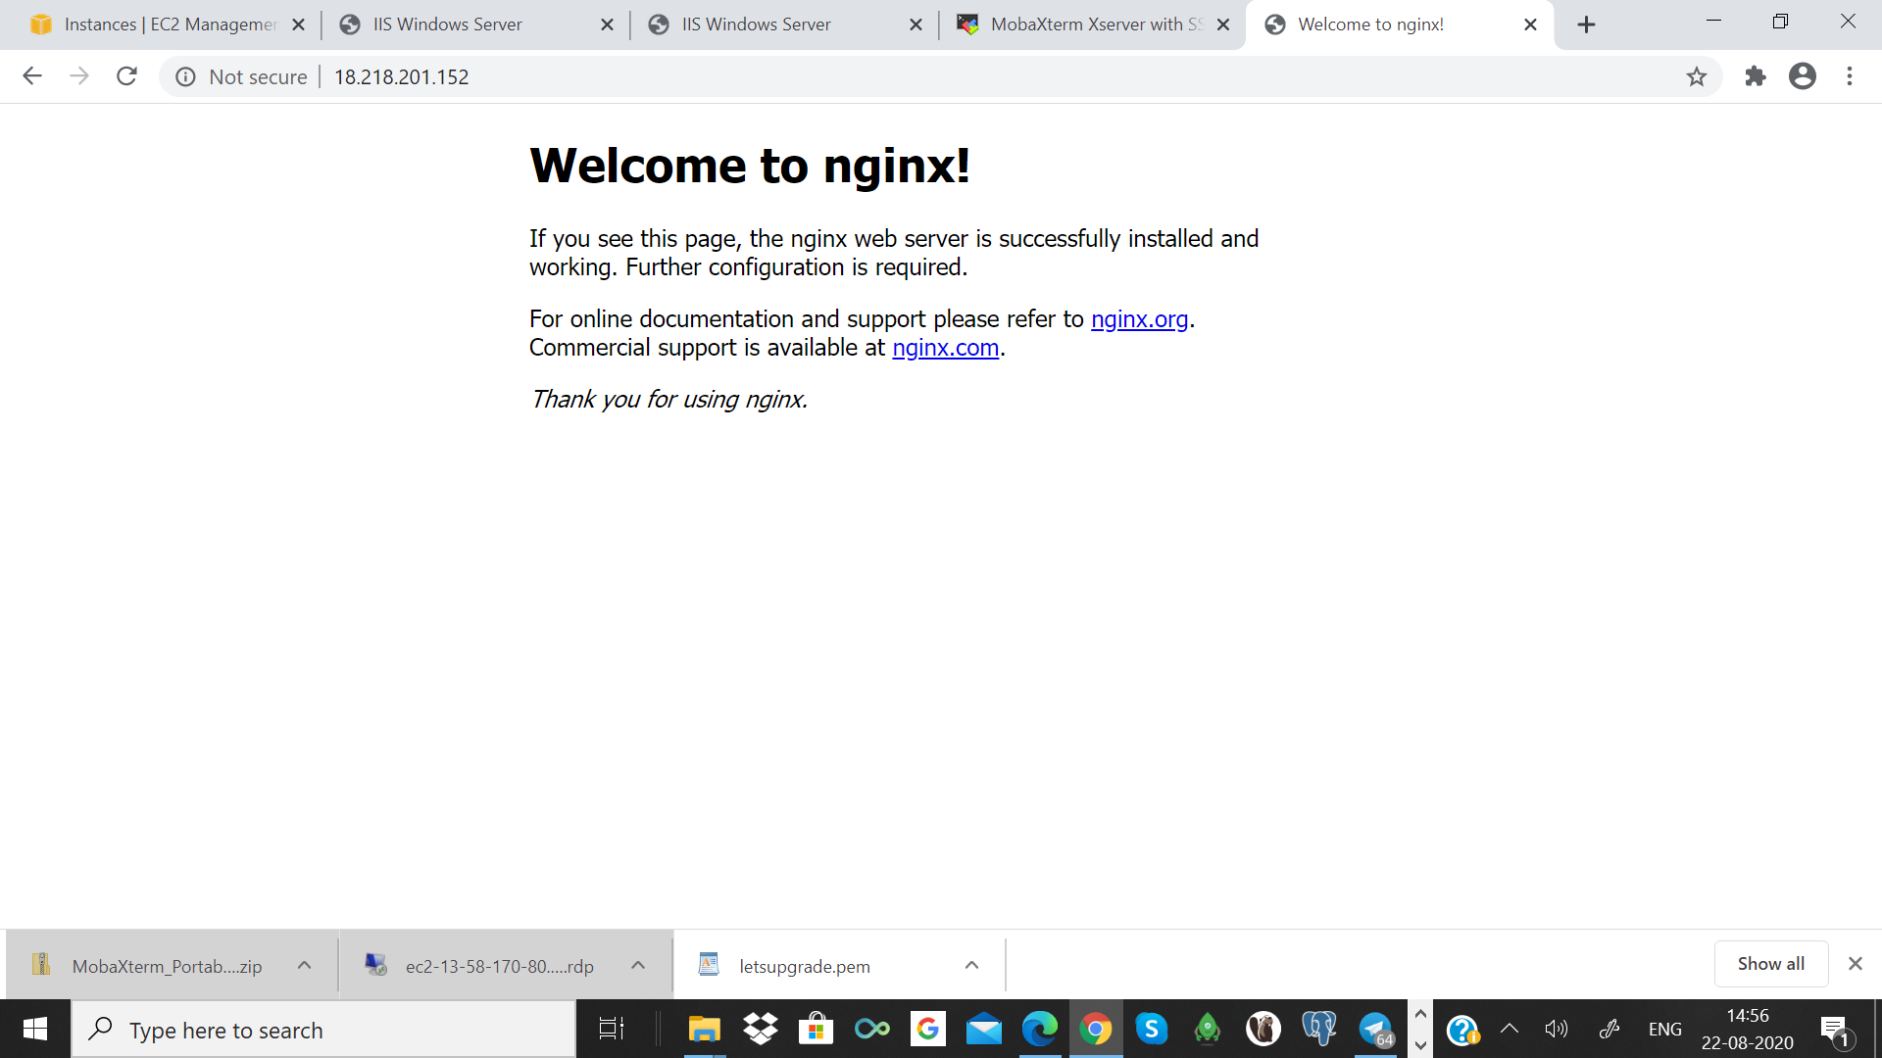

Connected Using MobixTerm

